# **SQL Database**

This demo is about creating an SQL server Database and working with it using an application. The setup includes SQL server creation, configuring firewall, connecting to SQL database and inserting data to it.

**Creating SQL DB:**

In the azure portal, go to **+ Create a resource -> Database -> SQL Database.**

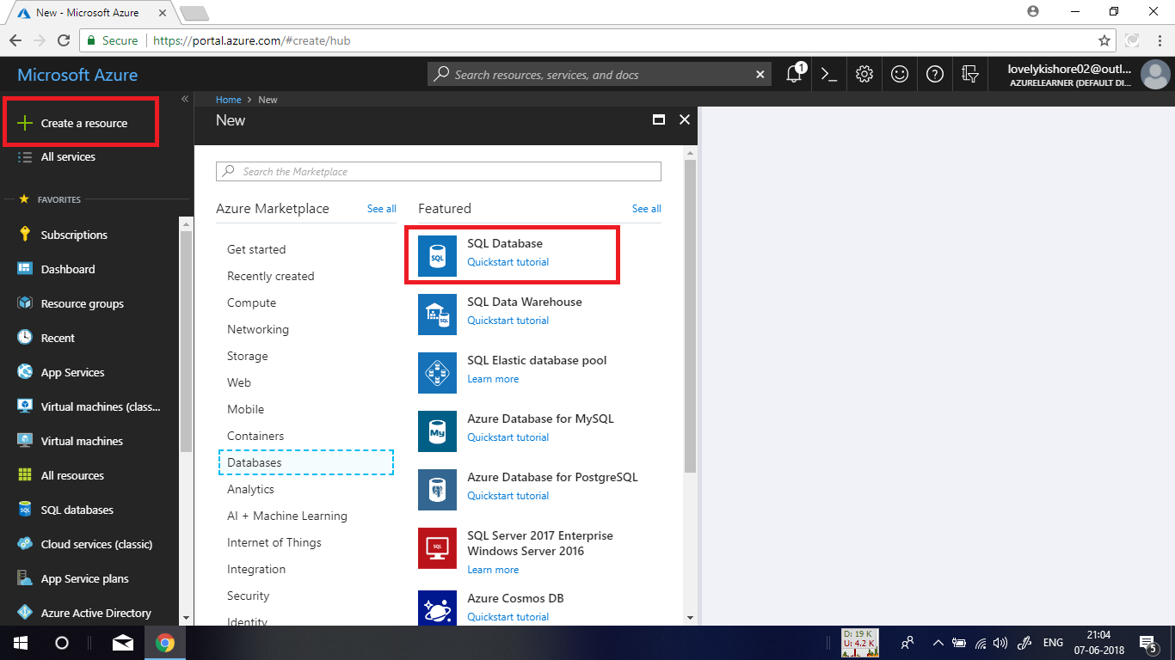

Give an unique name and choose a subscription and a resource group. Let it be a blank database. Create a server with a name and username and password as denoted in the below given image and deploy the database.

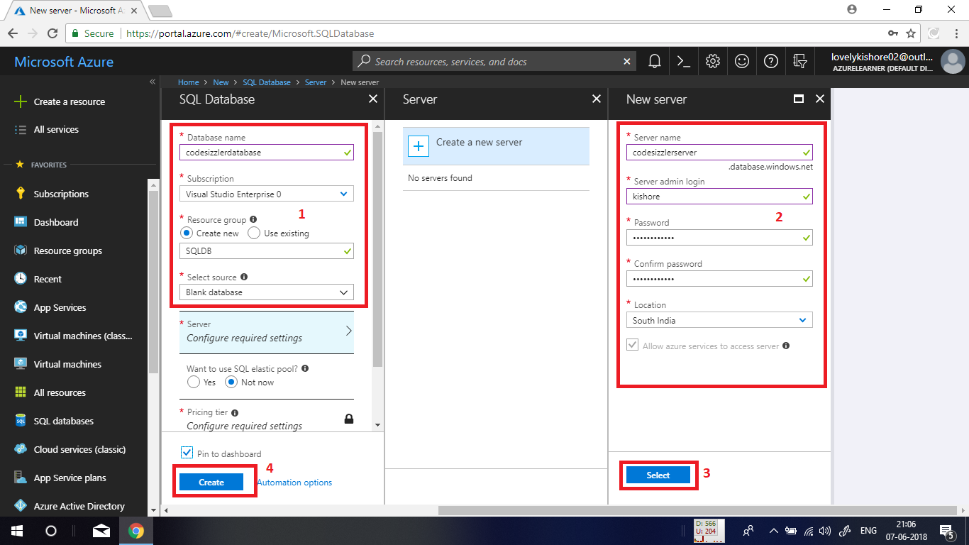

**Configuring Firewall:**

In the overview bladed of database, click on the set server firewall option to configure access to the server.

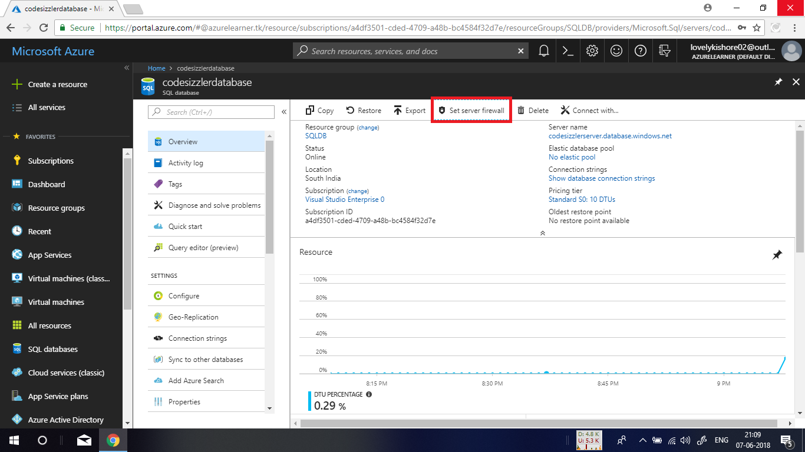

After that click on the **+** **Add client IP** option to add your machines IP to have access to the server. If in case you want to allow access for an entire organization, you can manually add the IP ranges as allowed address in the option denoted below. After adding the IP, click on save button.

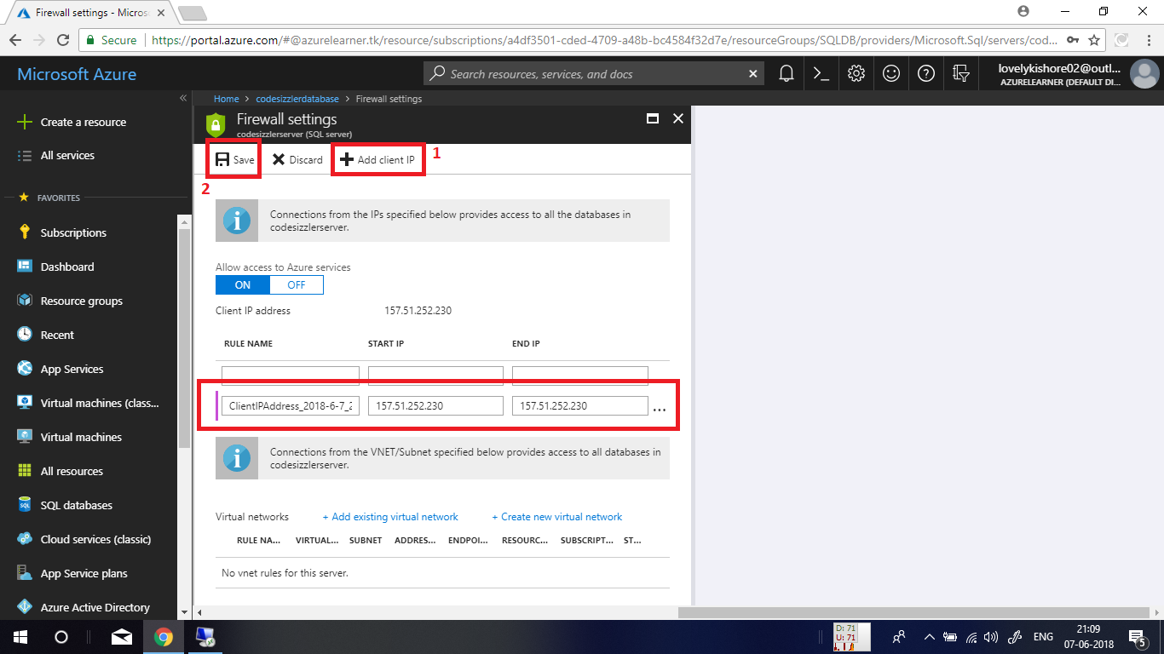

**Connecting to SQL database from Visual Studio:**

Open Visual studio and go to **view->Server Explorer** to open server explorer. In there, right click on the Azure symbol that is denoted in there and choose Connect to **Microsoft Azure Subscription**. Then sign in to azure by entering your azure account credentials.

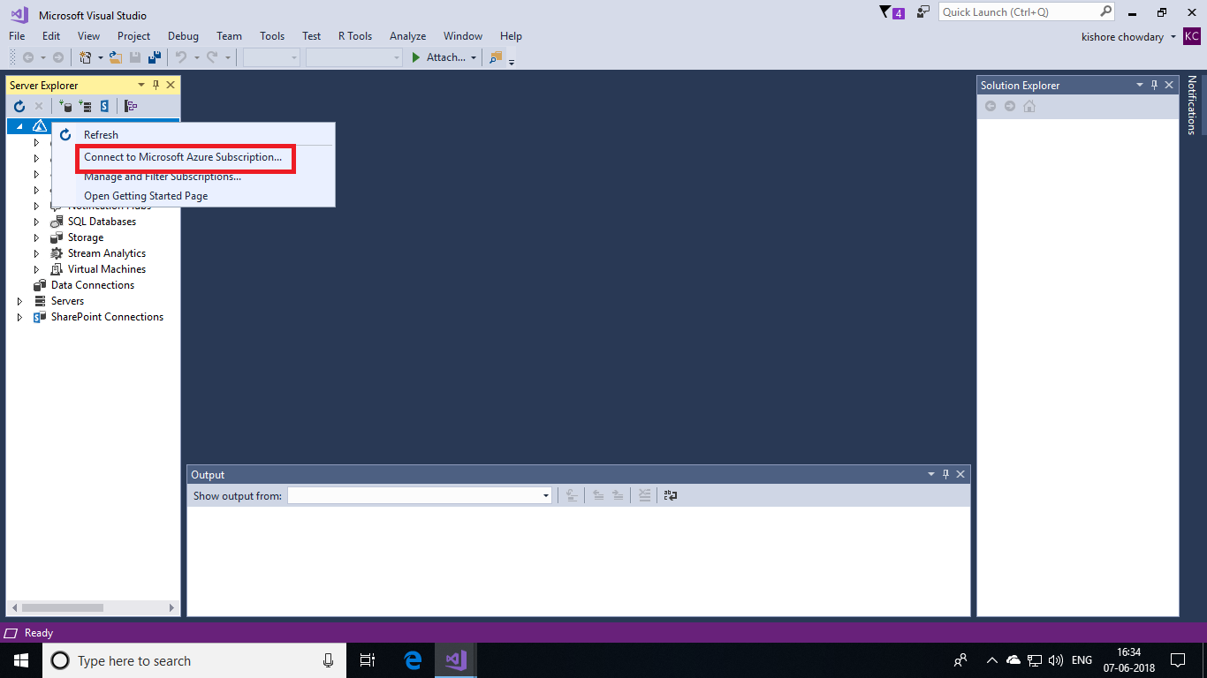

Once after your login, all the resources in your subscription will be displayed in the server explorer pane. There right click on **Data Connections** and choose **Add Connection**.

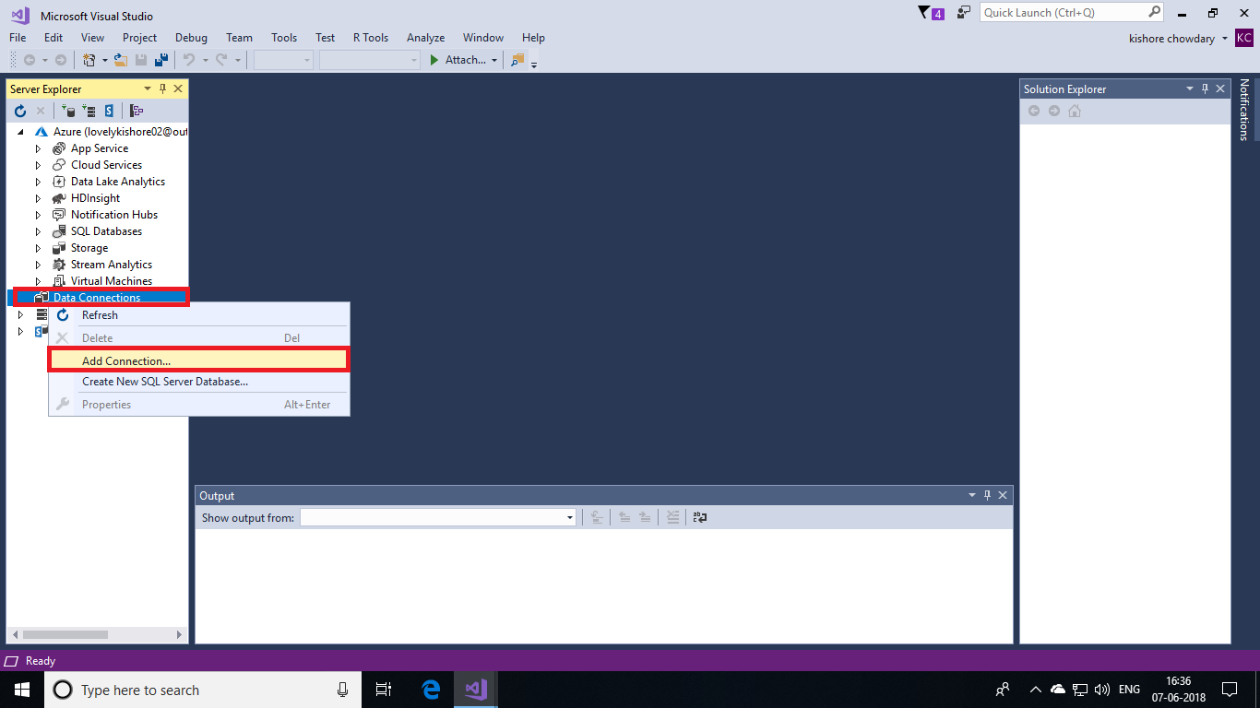

In the next window, choose **Microsoft SQL Server** and click on **Continue**.

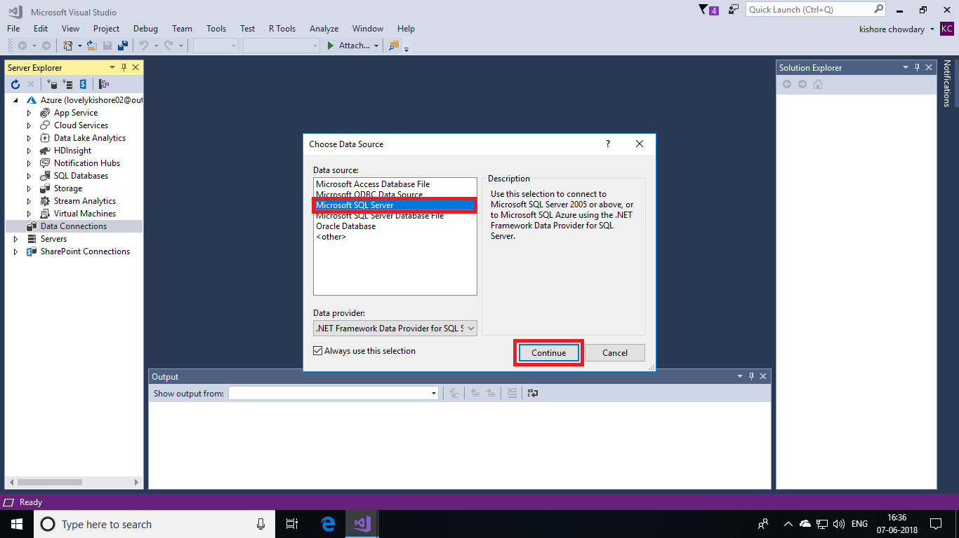

In the next window, enter the **DNS** of your SQL server. You can find the address in the overview page of your SQL Database that you created in azure portal. Next choose **SQL Server Authentication** for authentication and enter the **username** and **password** of your SQL server. Next choose the database that you created in azure portal from dropdown list. Make sure to select the appropriate options. If you miss any, you won’t be able to execute the demo correctly. After choosing all the options, click on **Ok** button.

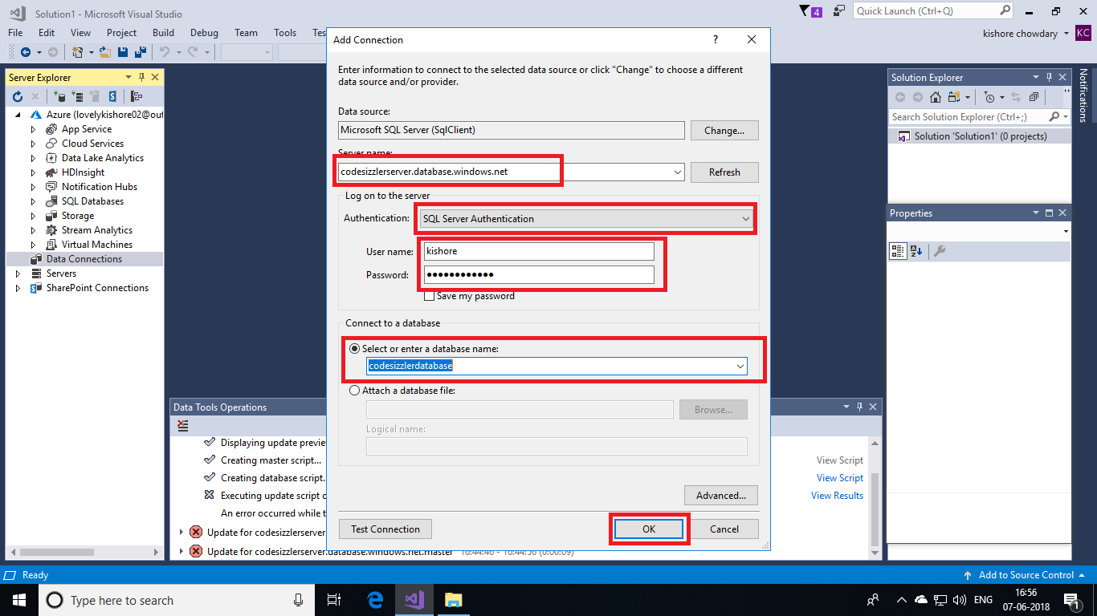

After a successful connection database, you can find the database connected in the left side menu under **Data Connections** menu. Expand it and under your database, find **Tables** option and right click on it. Then click on **New Query** button.

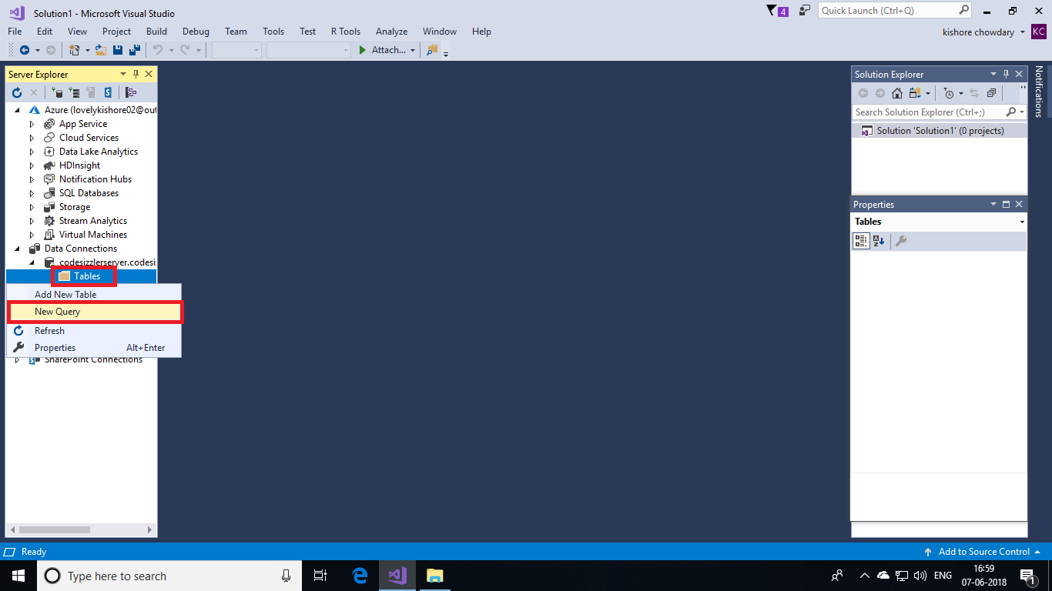

**Creating Table:**

You will be now displayed with a querying table. In there, enter the query to create a database table. After that click on execute button in the top left corner to execute the script. After the successful execution of script you will get an output stating that table is created. The code is as follows.

**CREATE TABLE [dbo].[empTable]**

**(**

**[Id] INT NOT NULL PRIMARY KEY IDENTITY,**

**[emp_id] INT NULL,**

**[name] NVARCHAR(50) NULL,**

**[education] NVARCHAR(50) NULL,**

**[email] NVARCHAR(50) NULL**

**);**

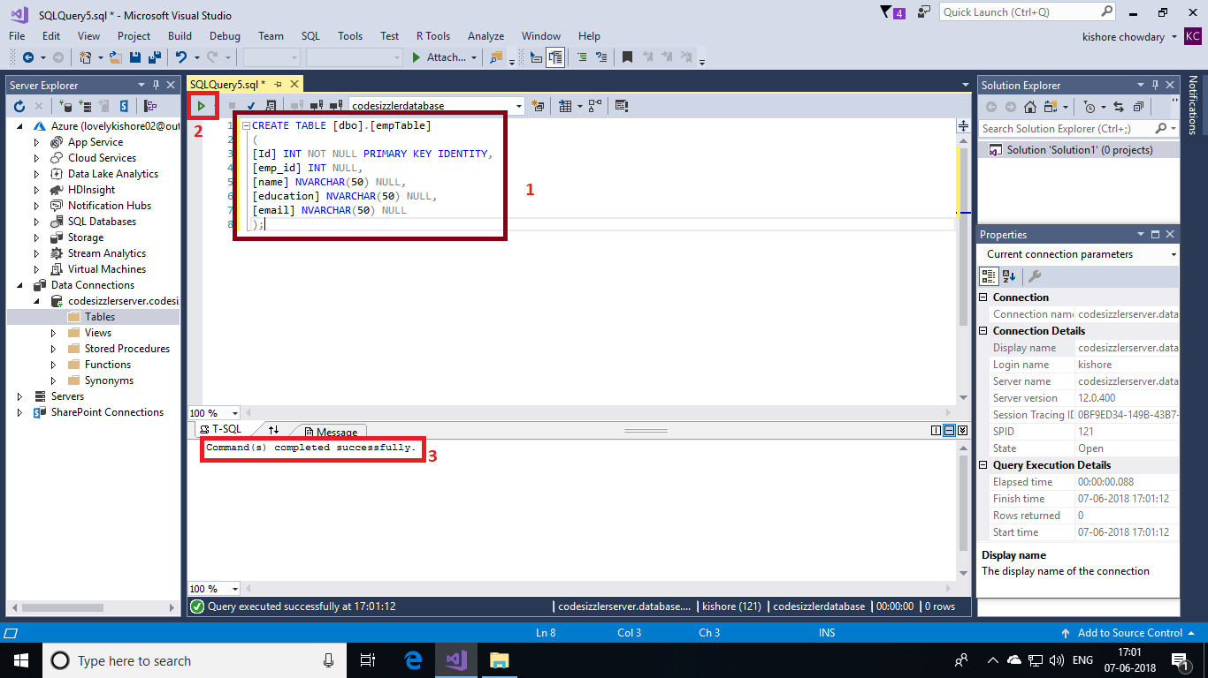

**Creating an ASP.Net Application to Insert Data into Database:**

In Visual Studio, go to **File->New->Project**.

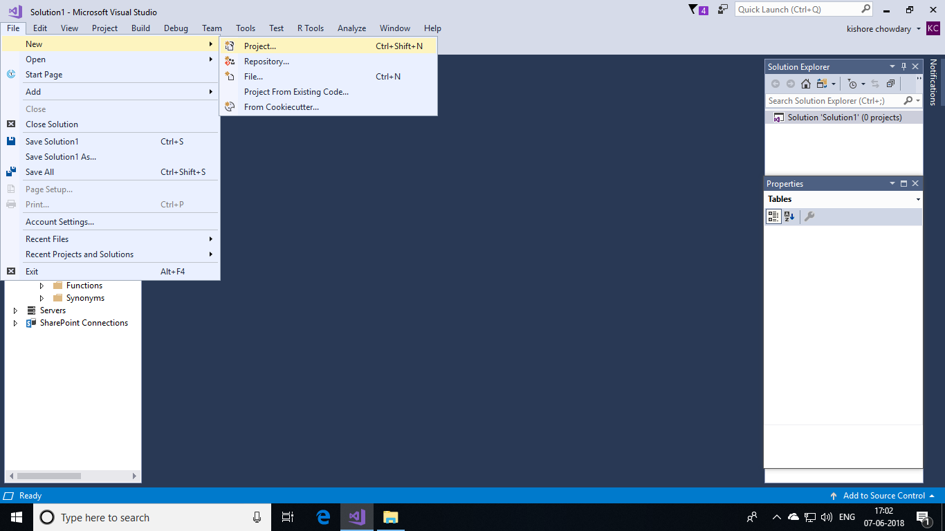

Next, choose **web** in the left side menu and select **ASP.NET Web Application** as template. Name it as **CodeSizzlerSQLDemo** and click on **OK** button.

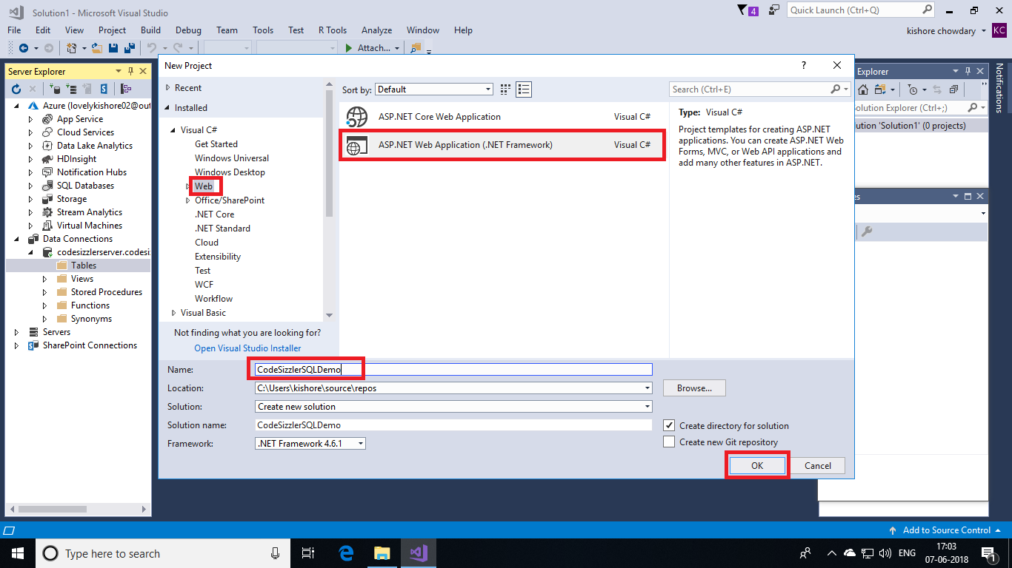

Choose **Empty** project and click on **Ok.**

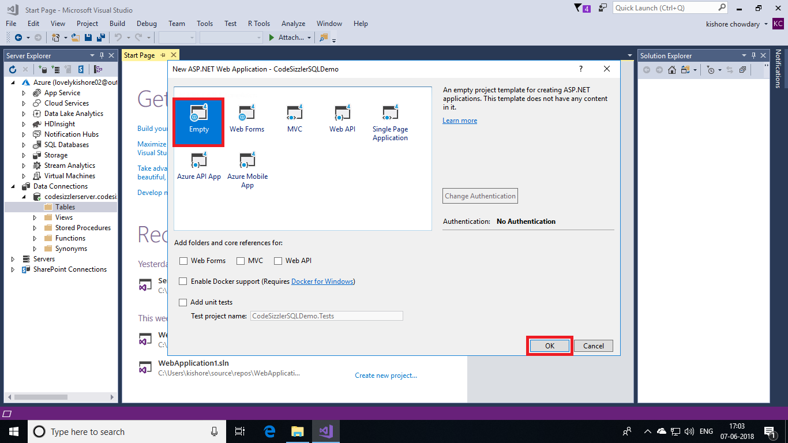

After the solution gets deployed, right click on the solution name and go to **Add->Web Form**.

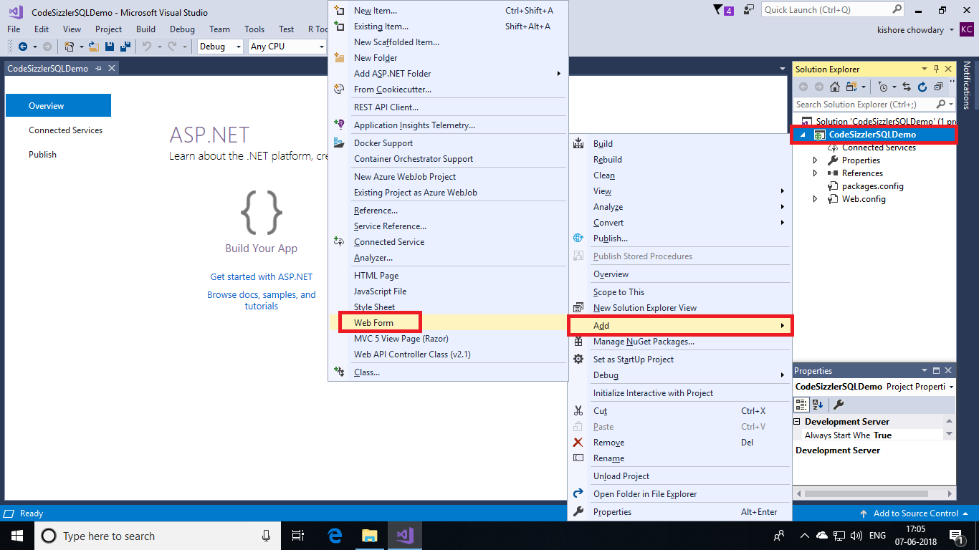

Name the form as **index**.

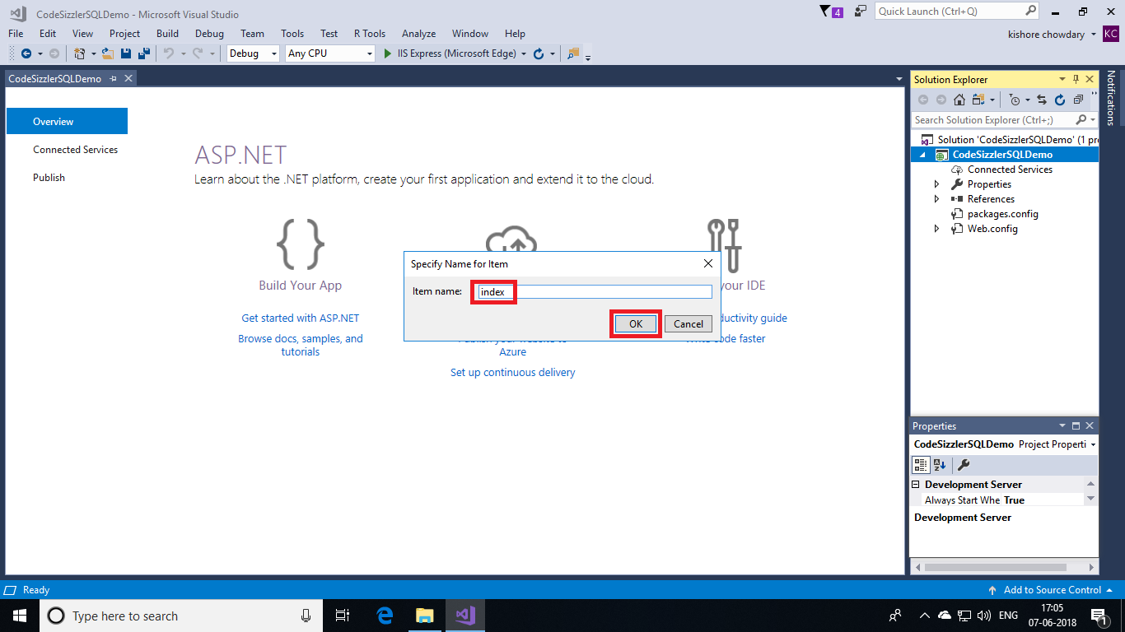

In the web form that you added now, replace the default code in there with below given code.

**Indez.aspx:**

<%@ Page Language="C#" AutoEventWireup="true" CodeBehind="index.aspx.cs" Inherits="SQL_ASPDOTNET.index" %>

    <!DOCTYPE html>

    <html xmlns="http://www.w3.org/1999/xhtml">

    <head runat="server">

        <title>Azure SQL Database - Sample</title>

        <style type="text/css">

            .style1 {

                color: #FF0066;

                text-decoration: underline;

                font-weight: bold;

            }

        </style>

    </head>

    <body>

        <form id="form1" runat="server">

            <table align="center" cellpadding="4" cellspacing="2" style="border: 1px solid #999999; font-family: Century">

                <tr>

                    <td colspan="3" style="text-align: center;">Employee Form</td>

                </tr>

                <tr>

                    <td width="100px">Emp Id</td>

                    <td width="5px" rowspan="8" style="border-right-style: solid; border-right-width: 1px; border-right-color: #999999"></td>

                    <td width="200px">

                        <asp:TextBox ID="TextBox1" runat="server"></asp:TextBox>

                    </td>

                </tr>

                <tr>

                    <td>Name</td>

                    <td>

                        <asp:TextBox ID="TextBox2" runat="server"></asp:TextBox>

                    </td>

                </tr>

                <tr>

                    <td>Education</td>

                    <td>

                        <asp:TextBox ID="TextBox3" runat="server"></asp:TextBox>

                    </td>

                </tr>

                <tr>

                    <td>E-mail</td>

                    <td>

                        <asp:TextBox ID="TextBox4" runat="server"></asp:TextBox>

                    </td>

                </tr>

                <tr>

                    <td> </td>

                    <td>

                        <asp:Literal ID="Literal1" runat="server"></asp:Literal>

                    </td>

                </tr>

                <tr>

                    <td></td>

                    <td>

                        <asp:Button ID="btnSave" runat="server" Text="Insert" onclick="btnSave_Click" />

                        <asp:Button ID="btnClear" runat="server" onclick="Button1_Click" Text="Clear" /> </td>

                </tr>

            </table>

        </form>

    </body>

 </html>

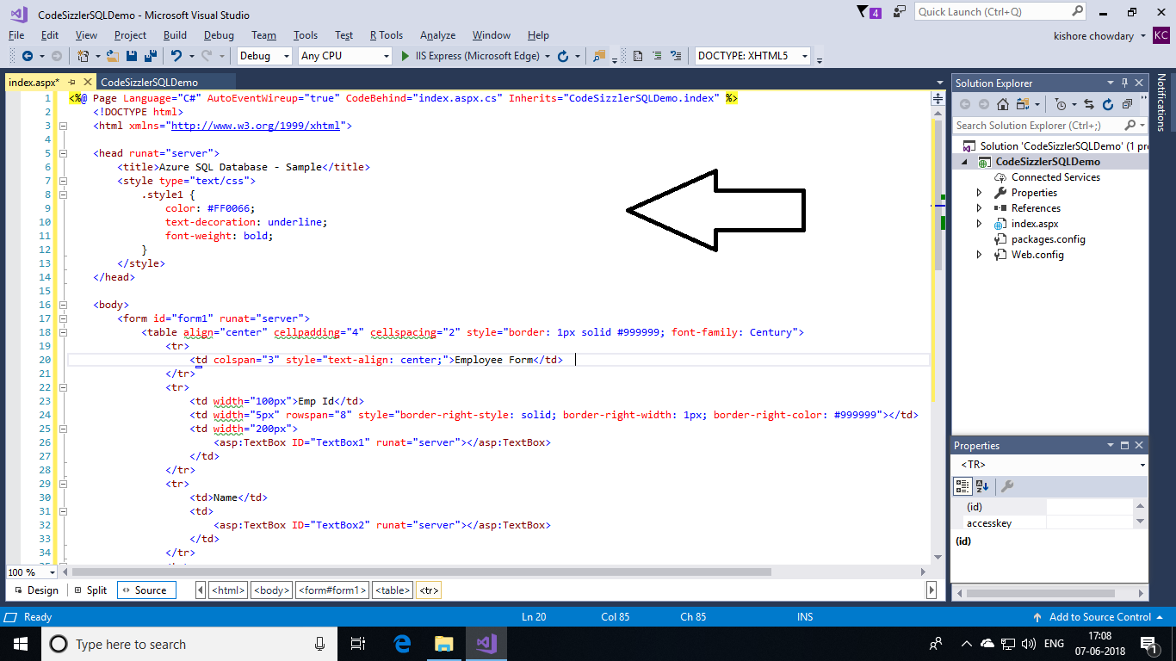

Next, we need to add code to **index.aspx.cs** page. This is for adding a logic code. Open the **index.aspx.cs** page and paste the below given code in there and replace the data source with your **SQL** **server DNS**, database name with **your database name**, your SQL **user ID** and **password** and save it.

**index.aspx.cs:**

**using** System;

**using** System.Collections.Generic;

**using** System.Data;

**using** System.Data.SqlClient;

**using** System.Linq;

**using** System.Web;

**using** System.Web.UI;

**using** System.Web.UI.WebControls;

**namespace** SQL_ASPDOTNET {

**public** partial **class** index: System.Web.UI.Page {

        SqlConnection con = **new** SqlConnection("Data Source=servername.database.windows.net;Initial Catalog=mssql;User ID=username;Password=password");

**protected** **void** Page_Load(**object** sender, EventArgs e) {}

**public** **void** clear() {

            TextBox1.Text = "";

            TextBox2.Text = "";

            TextBox3.Text = "";

            TextBox4.Text = "";

        }

**protected** **void** btnSave_Click(**object** sender, EventArgs e) {

            SqlCommand cmd = **new** SqlCommand("insert into empTable(emp_id,name,education,email) values('" + TextBox1.Text + "','" + TextBox2.Text + "','" + TextBox3.Text + "','" + TextBox4.Text + "')", con);

            cmd.CommandType = CommandType.Text;

**try** {

                con.Open();

                cmd.ExecuteNonQuery();

                Literal1.Text = "Data inserted successfully";

                con.Close();

                clear();

            } **catch** (Exception ex) {

                Literal1.Text = ex.Message;

            }

        }

**protected** **void** Button1_Click(**object** sender, EventArgs e) {

            clear();

            Literal1.Text = "";

        }

    }

}

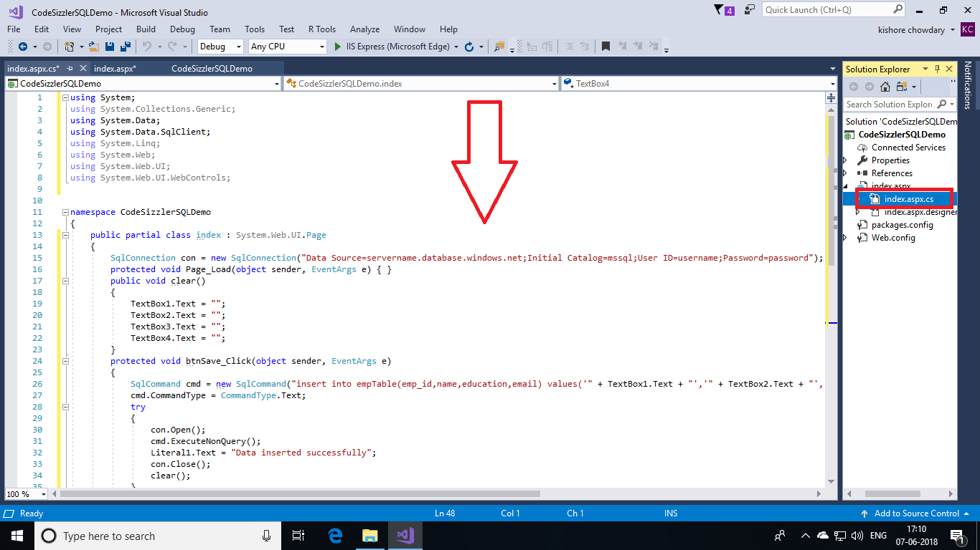

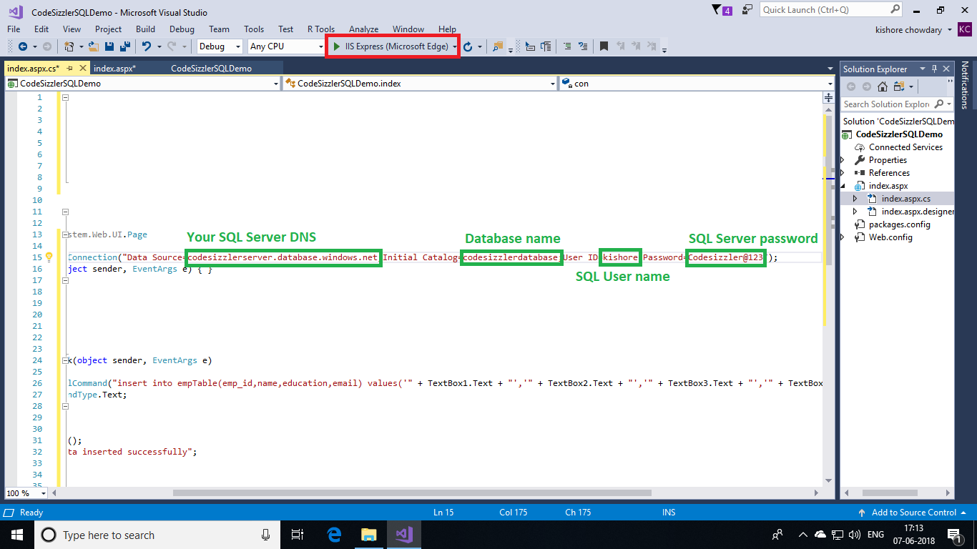

After saving the solution, click on **execute button** that is in top or press **F5** to see the output. In the output screen, enter the data and click on **Insert** button to save data into azure SQL database.

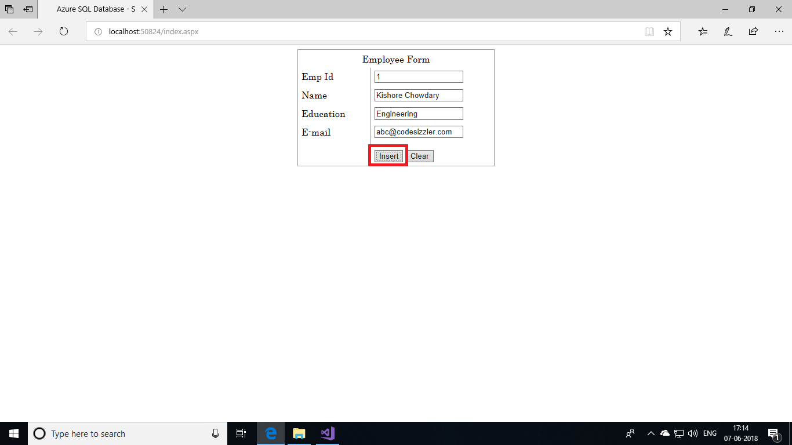

On successful insertion of data, you can find a response as following.

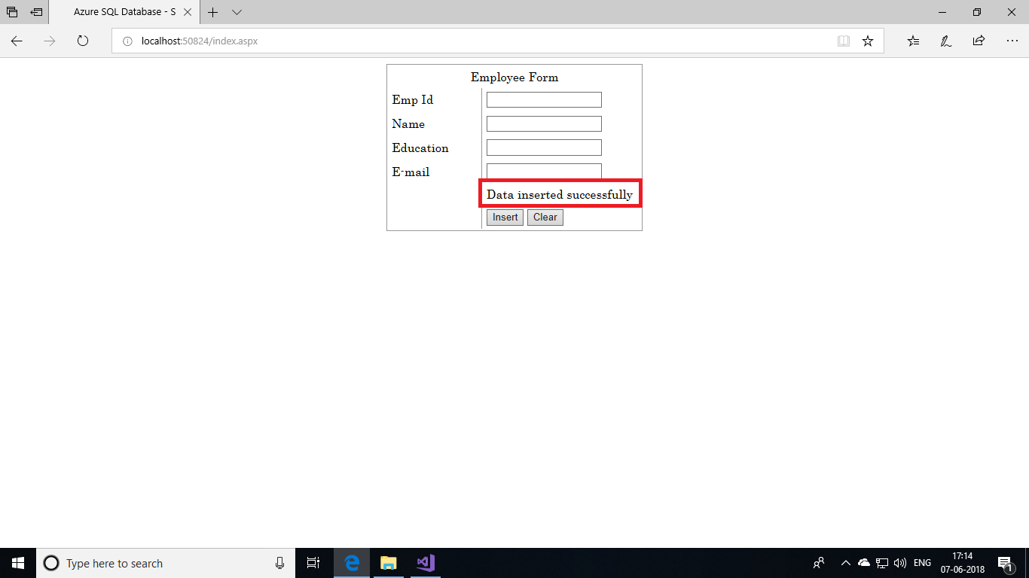

**Viewing Inserted Data:**

Go to solution explorer in the view menu.

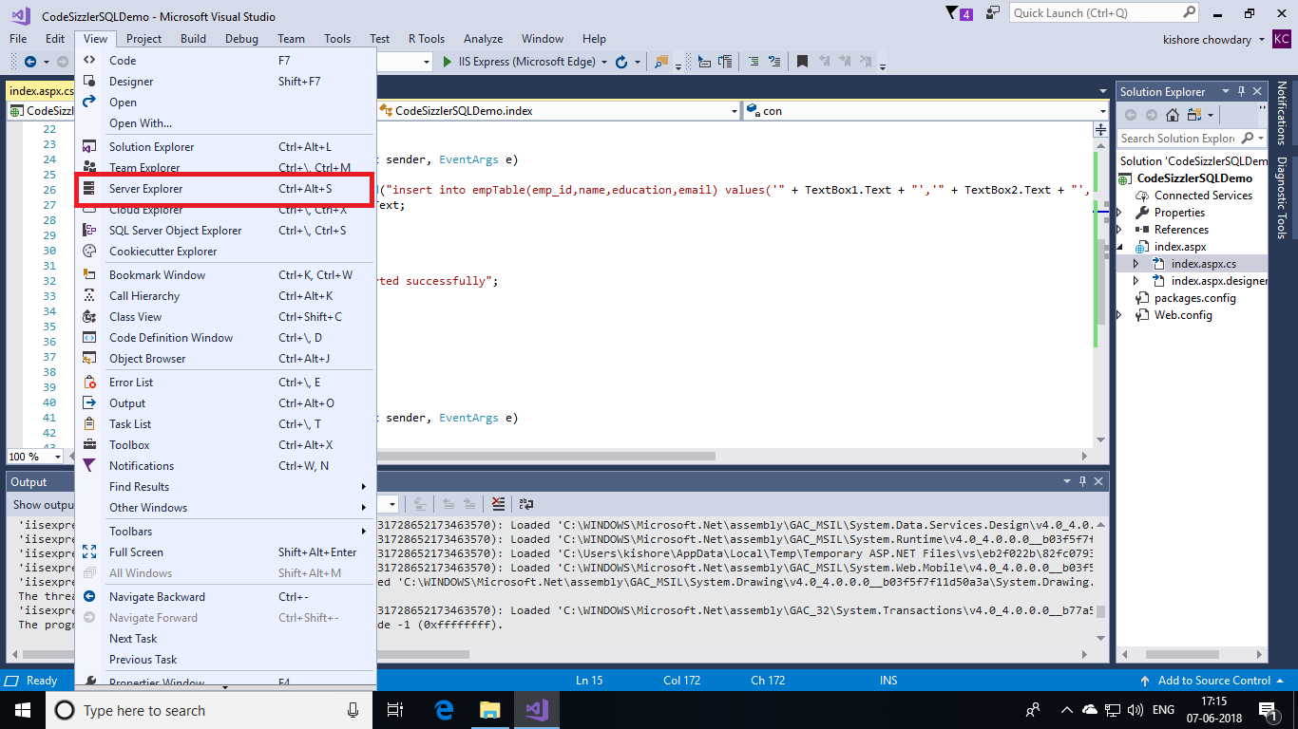

Under the table menu, right click on the table that you created and choose **Show Table Data.** You will be shown with a table that holds your data in azure SQL database.

